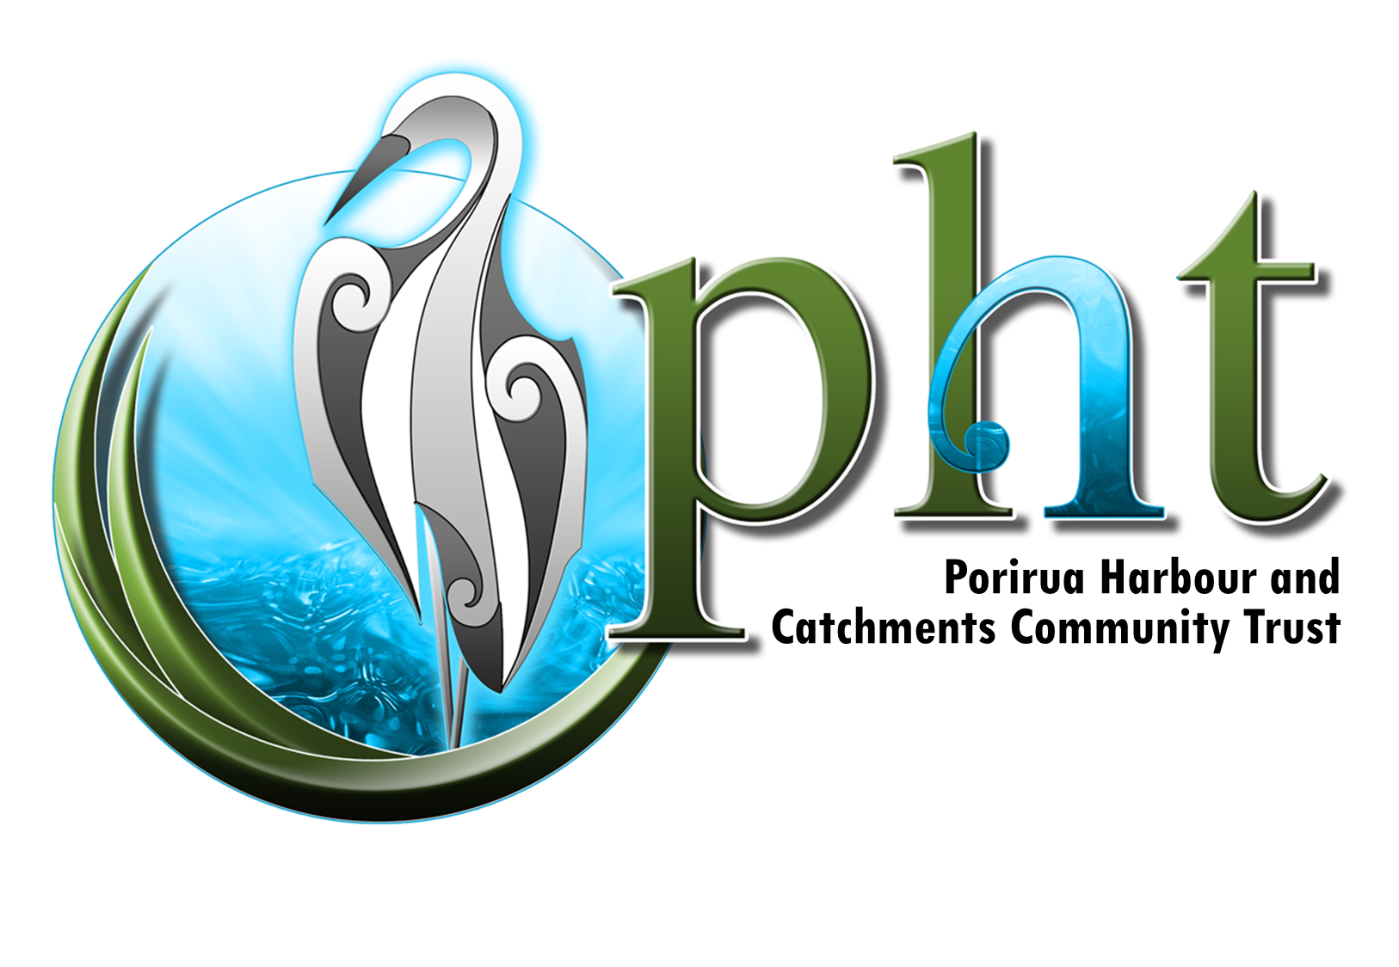

**ANNUAL REPORT 2022/23**

I have the pleasure of presenting the annual report for 2022/23 of the Te Awarua o Porirua Harbour and Catchments Community Trust.

**Introduction**

The Te Awarua o Porirua Harbour and Catchments Community Trust was set up on 1 July 2020 as the truly independent successor of the the Porirua Harbour and Catchment Community Trust (marketed as the Porirua Harbour Trust) that had existed since 2011.

The objectives of the Trust’s deed are as follows:

* Advocating for the sustainable management of the harbour's ecosystem and

its catchments;

* Fostering the understanding of ecological and environmental issues

associated with the harbour and its catchments through education and

community awareness;

* Co-ordinating input from community groups on issues relating to the harbour

and its catchments;

* Supporting, promoting and contributing to programmes and projects aimed

at improvements to the Porirua Harbour ecosystem and its catchments;

* Fostering an understanding that the rural and urban areas around the

harbour have specific needs; and

* Engaging in any other activities and processes that are complementary to any

of the foregoing objectives including to promote or undertake research

**Strategic Direction**

The year from 1 July 2022 to 30 June 2023 was a year in which the Trust moved on from the focus of the previous trust and began to work in accordance with the strategic plan we developed the previous year <https://poriruaharbourtrust.org.nz/wp-content/uploads/2022/07/PHT-strategic-plan-final.pdf> . This has seen close attention paid to our advocacy and monitoring roles, especially given the volume of changes occurring at local, regional and central government level.

**Activities**

Update on harbour health by Greater Wellington Regional Council

The Trust was pleased to have an update from Megan Oliver, a senior environmental scientist with GWRC, on the overall state of the health of the harbour. This followed a similar presentation in 2019. The key takeaway points from the presentation were that not a lot had changed in the intervening three years and the overall health of the harbour was no better and, in some respects, worse. There continues to be a huge variation year by year of sediment events and stringent mitigation is required.

Sediment is not static in the harbour and shifts around. On the positive side much work is underway including the PCC award-winning riparian planting programme.

Photographic competition

Discussions at our half day strategy session held in November and subsequently produced a consensus that the Trust would aim to do one project at a time and do it well. As a member of the Porirua Camera Club as well as the Harbour Trust, Christine Jacobson proposed we run a joint photographic competition. It was agreed that the Trust would partner with both the Camera Club and Mountains to Sea to run such a competition. Plans are now fully in place to conduct the competition in late 2023 with the results to be exhibited in the Bottle Creek Gallery at Pataka between 2 February and 31 March 2024. This will be an ideal project to graphically portray to the local community and visitors from across Greater Wellington the multi-dimensional nature of our harbour as a key taonga of Ngāti Toa and the wider community. We are grateful to a growing number of sponsors and supporters for this event including Porirua City Council, Trust House, Epson, Jason Clark Real Estate, Andrew Lamb of the Communications Collective and the Whānau of the late Thom Kenny,

Presentation to Whitby Residents Association

In April, at the invitation of Saar Cohen-Ronen, Lindsay Gow and I attended the annual general meeting of the Whitby Residents Association. I spoke briefly about the role of the Trust and Lindsay gave a very well received presentation on Whitby waterways and their relationship with the Inlet. The presentation was very well received and led to many questions particularly about the health of the Whitby Lakes.

Research on Seagrass

Thanks to the Porirua City Council several trustees attended a meeting with Dr Inigo Zabarte-Maeztu of NIWA to hear the results of his research on seagrass. Inigo reported that seagrass meadows in our harbour continue to be in retreat, especially on the western side of Pāuatahanui Inlet where they have all but disappeared. Seagrass needs light and is healthiest at the bridge end of the inlet and out from the end of Goldengate. Seagrass is also present at the top of the Onepoto arm out from Titahi Bay road and near the Paremata railway station. Inigo reported that the Cawthorn Institute had some success in replanting seagrass in estuaries and had produced guidance on cultivation techniques.

Submissions

The 2022/23 year was also a busy one for submissions. The Trust made submissions on the Spicer Landfill development, the proposed Northern Porirua Housing development and the Spatial Planning and Natural and Built Environment Bills. The Chair and Phil Teal appeared by Zoom at the Select Committee hearing the Spatial Planning and Natural and Built Environment Bills and Lindsay Gow and Mark Neeson appeared before the Hearing Panel on proposed District Plan variations for the northern housing area and intensification throughout Porirua city. A common theme running through our submissions was the need for water sensitive urban design requirements for any developments.

Survey of local body candidates

The Trust joined with the Guardians of Pāuatahanui and the Friends of Taupo Swamp in surveying candidates standing for the Porirua City Council, the Regional Council and the Northern and Tawa wards of the Wellington City Council. Of the 40 candidates polled 17 provided replies which were then published on our website and facebook page.

Kainga Ora presentation on housing development

In December, trustees along with representatives of other community groups attended a presentation by officials from Kainga Ora concerning that organisation’s plans for intensive housing development in northern Porirua. The officials described the parcels of rural land being consented for development in northern Porirua as the largest greenfields housing area in the lower North Island. Trustees are concerned that use of the Urban Development Act by Kainga Ora in future developments may not fully protect the sensitive catchments that feed into the harbour. We will monitor development of proposals and look forward to officials promising to consult the community fully on any such work.

Proposed global consent for stormwater

In February, officials of Wellington Water Ltd presented their draft strategy on stormwater to the Trust. Consent proposals for global consents for streamworks and wastewater in the four cities (Wellington, Porirua, Hutt and Upper Hutt) are due to be lodged in August 2023. The Chair of the Trust has been participating in a focus group with WWL on a community engagement model that will be part of the consenting process.

Te Hononga Ki Te  
Upoko/Wellington Catchments Collective

As Chair of the Trust I was pleased to participate in the first online meeting of Te Hononga Ki Te Upoko which aims to bring together representatives of catchment restoration groups from throughout the greater Wellington area. The collective works on the principles of sharing knowledge, experience and best practice. Saturday morning hikoi around various participating catchments will be another feature of the new collective.

Another year of little progress on Whaitua implementation

It is disappointing to report another year has gone by with little progress on implementation of recommendations in the Te Awarua o Porirua Whaitua Report of 2019. A proposed Harbour Accord that would involve Ngāti Toa, GWRC, PCC and WCC has made slow progress. The Trust has received consistent advice from elected representatives and officials alike that the uncertainty related to central government reforms, implementation of the National Policy on Freshwater, restructuring of GWRC and highly stretched budgets have combined to stall progress on the Accord. The Trust remains hopeful that faster progress will be made in 2023/24. Meanwhile good progress is being made on delivery of the riparian planting programme led by Porirua City Council. This multi-year programme is the single biggest initiative to reduce sediment flows into the harbour and it is great to see evidence of widespread plantings in key streamside, wetland and harbourside areas.

**Objectives for 2022/23**

* Three submissions to Council plans, consent applications and central government draft legislation *Achieved*
* Fill two trustee vacancies *Achieved (for part of year)*
* Fill vacant voluntary secretary role *Not achieved*
* Review activity plans at a strategy day and agree on priority actions for year ahead *Achieved*
* Maintain website and facebook presence. Our website had an average of 145 user visits per month and facebook page reach of 173 with 562 followers - *Not achieved (lower traffic)*
* Liaison with elected councillors, officials, guest speakers and harbour stakeholders *Achieved*

**Financial**

The Trust continues to cover minor administration expenses are from reserves. In June we also took receipt of a $1000 grant from Trust House to help fund expenses associated with the photo competition. Therefore, at the end of June 2023 our overall account has a balance $9713. The trust has agreed with partners of the photo competition to be the ‘banker’ for receipt and spending of any sponsorship funds acquired for the Harbour Photographic competition in 2023/24. The Trust has also endorsed the spending of the $1,683.00 tagged grant (rounded up to $1700) for education purposes by Mountains to Sea on working with schools in relation to developing harbour photography among pupils.

**Management of the Trust**

The Trust was delighted to welcome two new trustees in August 2022 taking us up to a full complement of ten for the first time. Saar Cohen-Ronen brought his legal knowledge and skills to the table as well as representing the Whitby community. Steve Kenny as a member of the Ngāti Toa iwi brought a mana whenua perspective to our deliberations. Regretably, Steve was only with us a short while as competing commitments including a new job with the Porirua City Council as well as whanau responsibilities meant he resigned in June 2023. The Trust also was sorry to accept the resignation of Ray Baker-Underhill in February 2023. Ray had been on the Trust and its predecessor. He was an enthusiastic advocate on behalf of the Waka Ama clubs, had been on the committee of the Paremata Residents’ Association and had ties with the Porirua East community.

Recruitment activity to fill the two vacancies took place in June with expressions of interest expected to close on 7 July.

**Current Trustees**

Michael Player **(**Chair)

Daryl Hayes (Treasurer)

Ray Baker-Underhill (resigned May 2023)

Lindsay Gow

Christine Jacobson

Mark Neeson

Christine Stanley

Phil Teal

Saar Cohen-Ronen

Steve Kenny (resigned June 2023)

**Acknowledgement of support**

I would like to record my thanks to all trustees for their expertise, energy and commitment to see the purpose and objectives of the trust fulfilled: Lindsay Gow has enormous knowledge of environmental matters and policy analysis, Mark Neeson is a tower of strength relating to council agenda surveillance and submission writing. Phil Teal brings his laser like professional attention to key issues and is our video conferencing whizz, when needed. Christine Stanley continues to be our rural affairs champion, reminding us that 80% of the catchments area is non-urban land. Saar Conen Rohen contributes a fine legal mind to our discussions. Christine Jacobson has thrown her all into the harbour photographic competition and Daryl Hayes continues to keep us safe with his rigorous eye for detail on all matters financial.

Acknowledgement of the two departing trustees is recorded in the ‘management of the trust’ section above. It was gratifying to see the remaining members of the original ‘class of 2020’ trustees signing on for a further term. It is testament to their long term passion for the mission of harbour health restoration. Some of the trustees have indicated they may not remain for the full three years of the new term and we have all agreed to make orderly succession a priority. To that end expressions of interest from within the community are welcome at any time. While the Trust deed has a cap of ten trustees at any one time there is also a provision for Advisory Trustees.

The Trust continues to enjoy a good relationship with officials and advisors of the three Councils. The PCC Harbour Coordinator, Nigel Clarke, continues to be a key figure. For Ngāti Toa we value the regular contact with Robert McLean. We thank everyone with whom we had contact in 2022/23 for their cooperation and enthusiasm.

The Trust once again acknowledges the support of Rob Apperdio and Story Box for providing hosting of [www.poriruaharbourtrust.org.nz](http://www.poriruaharbourtrust.org.nz) as a our primary channel for the public on harbour and catchment news.

Phil Major, our honorary financial reviewer continues to provide a watchful eye over the Trust’s financial accounting and statement of performance and we thank him and his staff for their work.

I would also like to register thanks to Susan McLennan and the local management of the Ministry of Social Development for allowing us to use their meeting rooms for our monthly meetings. The security guards are unceasingly friendly even though our meetings are usually the last of their day. It is so good to again be primarily conducting meetings kanohi ke ti kanohi or face to face.

Michael Player

Chairperson

Te Awarua o Porirua Harbour and Catchments Community Trust

30 June 2023