Down the Drain:
Exploring Stormwater in our Catchment

Porirua Harbour Teacher PLD – March 7th, 2016

This professional development workshop for teachers in the Porirua Harbour catchment area was a collaboration between Enviroschools (Amanda Dobson) and the Porirua Harbour Trust (Rebecca Logan). Funding was provided by the Greater Wellington Regional Council for costs associated with the day (including teacher release funding), and also from the Philipp Family Foundation (who fund the PHT education programme).

It was a really successful day, with a wide range of guest speakers and activities for teachers. There has been a lot of interest from schools on the topic of stormwater and as such this workshop was fully booked.

PROGRAMME

9am Karakia, Introductions and Outline for the day

9:15 Porirua Harbour as an education context – Rebecca Logan

9:25 Significance of the harbour and catchment to Ngati Toa Rangatira
Guest speaker from Te Runanga o Toa Rangatira – Raewyn Klenner

9:45 Stormwater System – How does it work? What are the issues?
Guest speakers from Wellington Water Ltd – Andrew Samuel
and Porirua City Council – Keith Calder

10:20 MORNING TEA

10:45 How is water quality in the harbour and streams monitored?
Guest speaker from Greater Wellington Regional Council – Summer Greenfield

11:15 Stormwater Education: overview of student action/drain art project – Amanda Dobson

12:00 LUNCH

12:45 Art session with Pataka educators – Margaret Tolland and Esme Hanton
Creating stencil art to be used for school stormwater drains

2:45 Conclusion and Evaluations

PARTICIPATION

17 teachers from 10 schools attended:
Porirua School (2), Paremata School, Pukerua Bay School (2), St Theresa’s School (2), Pauatahanui School, Titahi Bay Intermediate, Windley School (2), Paparangi School (2), Churton Park, and Tawa College (3)

We were also joined by some other educators from the region: Sancia Duncan who is the water educator for the Kapiti Coast District Council, and Te Atawhai Kumar from Te Aho Tu Roa (which is the sister programme to Enviroschools delivered in te reo for Kura Kaupapa and Kohanga Reo).

PHOTOS

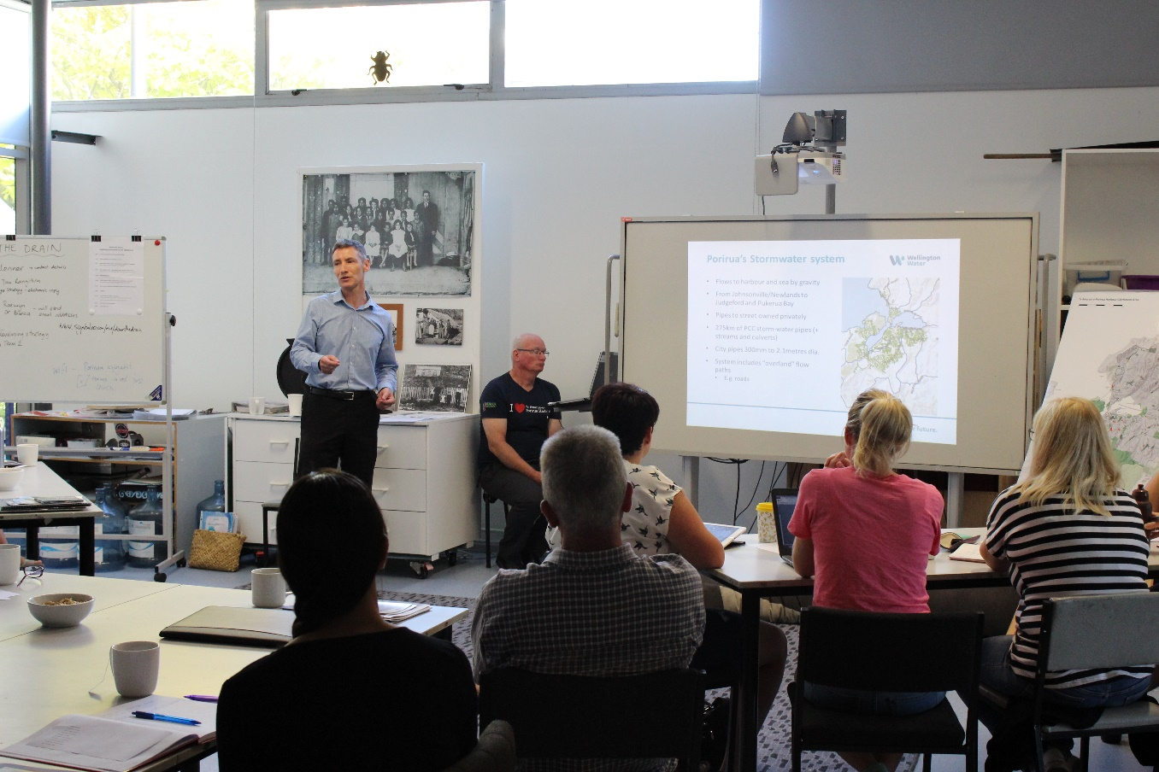

Above: Andrew Samuel (Wellington Water Ltd) explains the stormwater and wastewater systems to teachers.

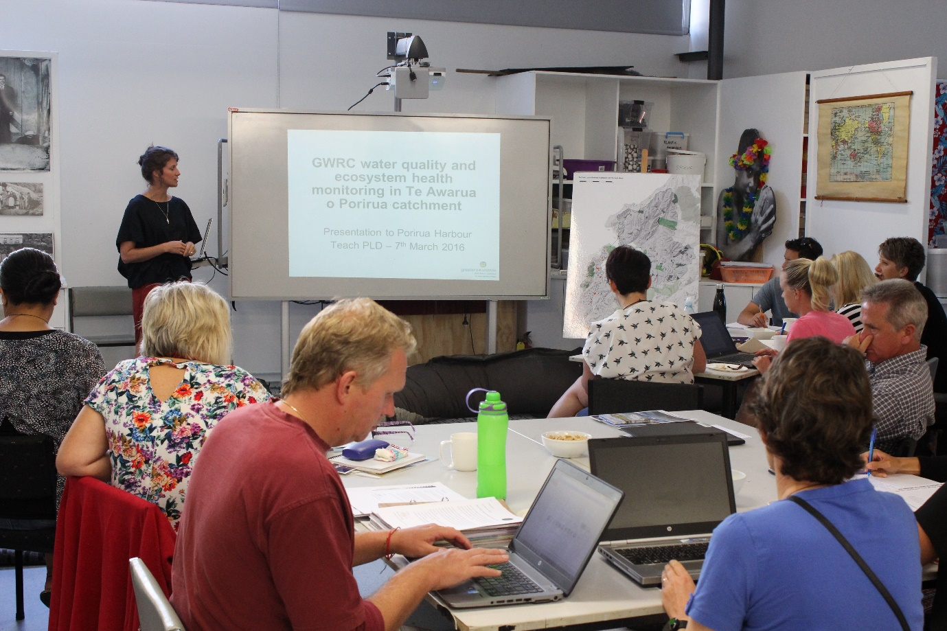

Above: Summer Greenfield (GWRC) discusses how water quality and ecosystem health in catchment streams and the harbour are monitored (including effects of stormwater and other pollution).

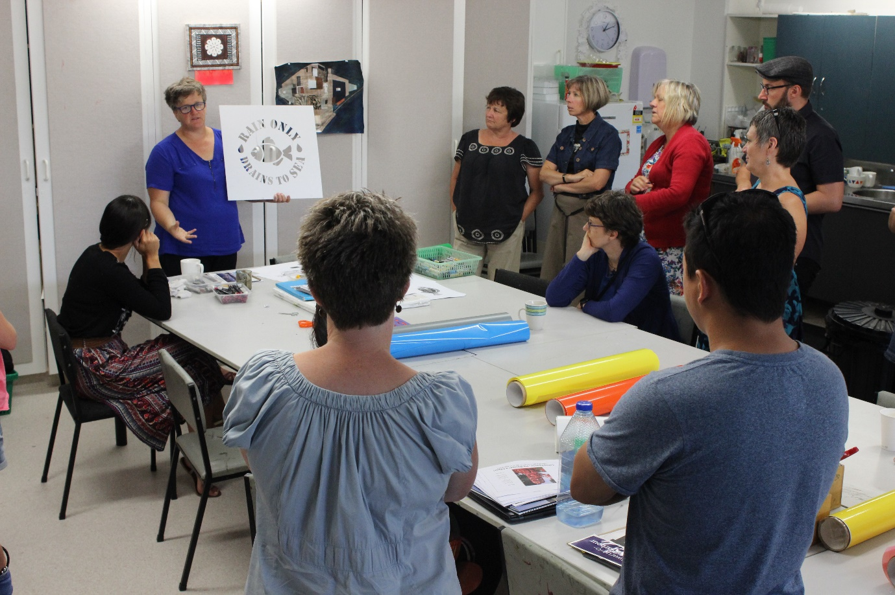
Above: Margaret Tolland (Pataka) begins to explain the process of producing a stencil, to create ‘drain art’ for stormwater drains.

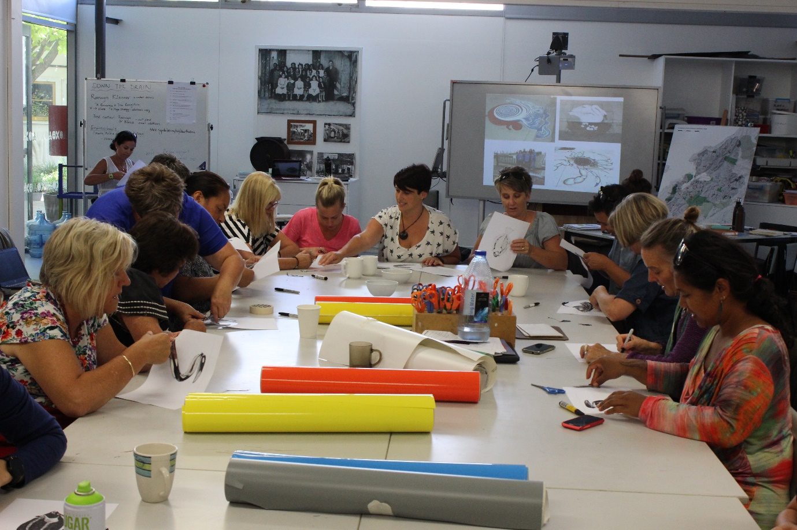

Above and below: teachers hard at work creating their own stencils!

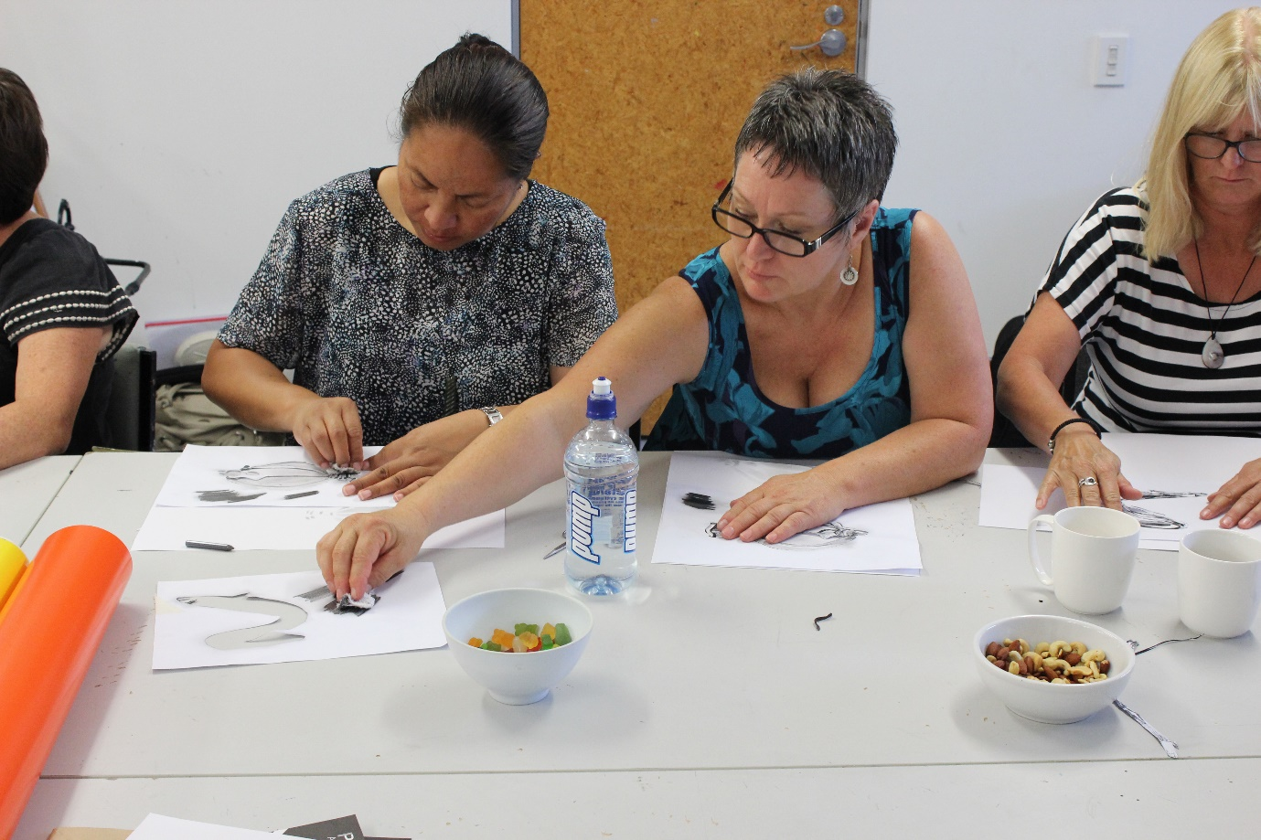

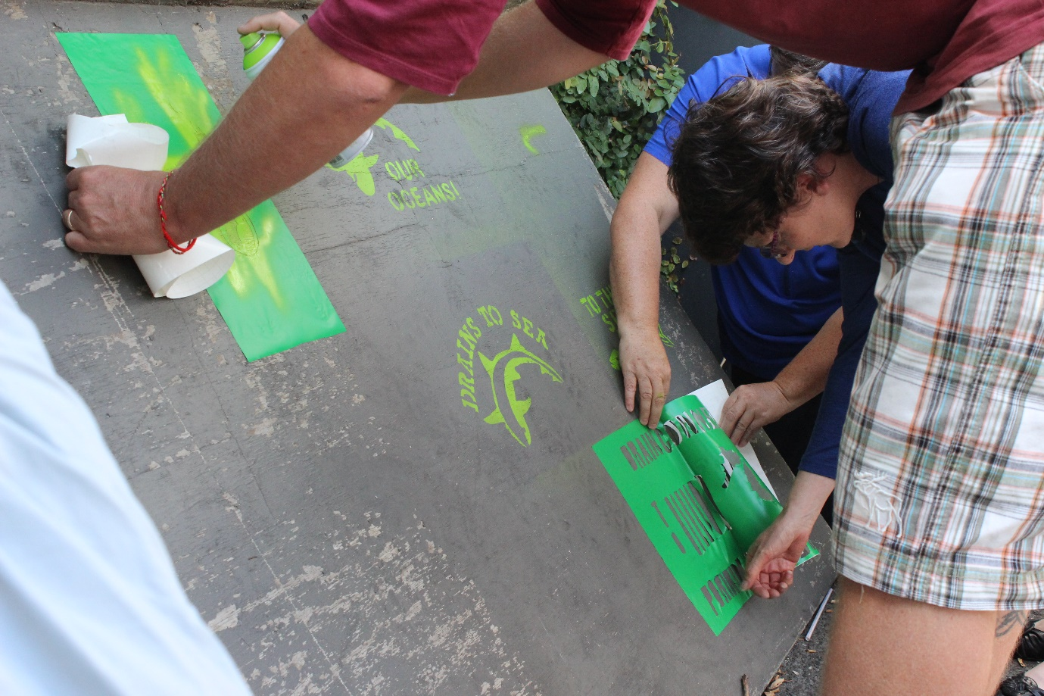

Above: Using spray paint to test stencils created by the teachers.

Below: The final product – examples of the drain art created by teachers.

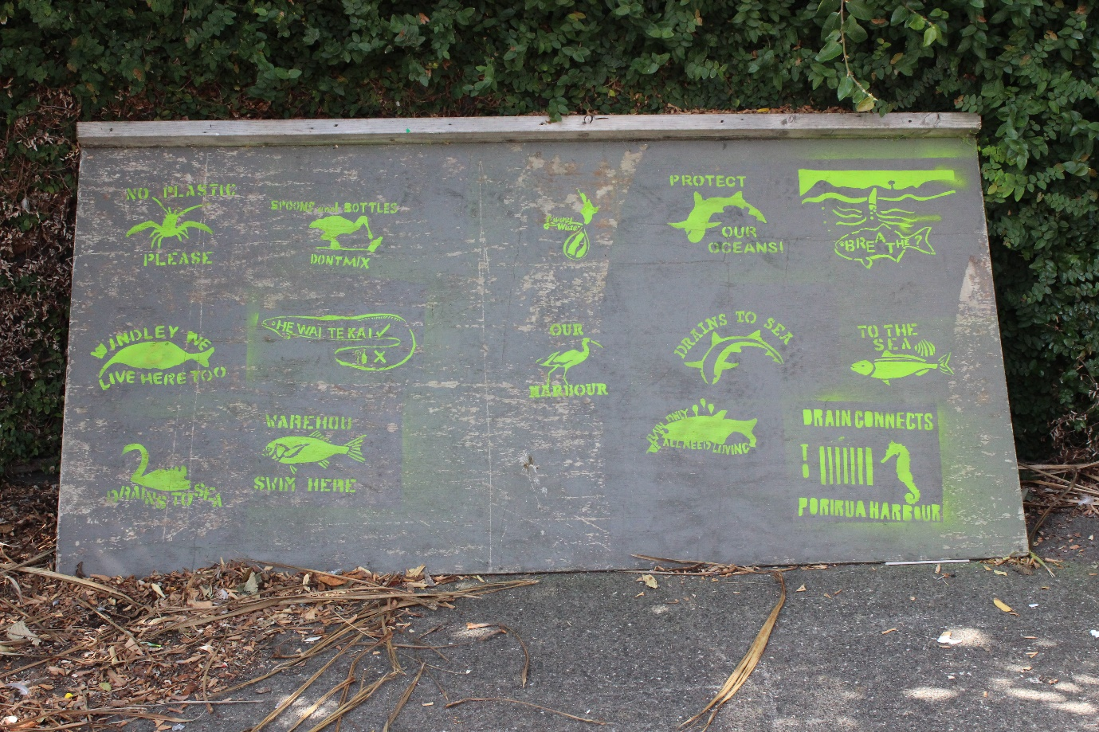

FEEDBACK

All of the teachers who attended this event were actively engaged and gave a high rating for relevance (when asked to rate relevance on a scale from 1 – 10). Most of them are planning to include the information and resources in their learning programmes (either in a wider context about Porirua Harbour, or specifically in a unit about stormwater and drain art).

Some of the main areas of interest and comments from the day included:

- It was valuable learning the difference between stormwater and wastewater.
- Great to connect with and hear from a range of people and organisations.
- Interesting to hear about testing of waterways and the different organisations involved.
- Good balance of various knowledge and activities – loved the variety.
- Liked the hands on and practical activities.
- George Nuku exhibition (and plastic bottle whare) gives valuable perspective and ideas for repurposing plastic bottles at school.
- Relevant and useful to support current school inquiry.
- Motivated to do an inquiry on stormwater and protecting the harbour.
- Catchment map is a great resource and good to share resources online.

FOLLOW-UP ACTIVITIES

Amanda has given a copy of the Drains are for Rain resource produced by Enviroschools, and will follow-up with all teachers by early Term 2, to see if they are planning to use the resource.

Rebecca and Amanda are keen to find ways to allow teachers to continue to share their ideas and resources, following on from the discussions we had at the workshop. Rebecca will survey the teachers to find out if they would be interested in attending follow-up cluster meetings, and/or being part of an online community.

The Porirua Harbour Trust will be holding an exhibition of student work related to the harbour, in November this year. Student drain art could be included as part of this proejct. Rebecca will be sending details about the exhibition to teachers soon.

