Porirua Harbour Teacher PLD – August 26, 2015

Te Awarua-o-Porirua Habour: Protecting our Taonga

This full day workshop was coordinated by Rebecca Logan, the Education Coordinator for the Porirua Harbour and Catchment Community Trust. We were very grateful to receive generous funding from the Philipp Family Foundation, which covered the teacher release costs, catering and resource costs. The venue was provided (no charge) by Pataka Art and Museum (Porirua City Council).

Curriculum Focus: Social Studies, Levels 3 – 5

Teachers in Attendance: 20 teachers (15 primary, 5 secondary), from 13 schools

Theme for the day: Join us as we explore the history of Te Awarua-o-Porirua Harbour, and how humans have affected this precious taonga. We will discuss our role as kaitiaki, and how we can support our students to take ownership of the protection of this unique habitat.
Programme:
The morning included discussions with guest speakers, and videos about the history and health of the harbour.
Linda Fordyce, from Pataka, gave an excellent overview of the early history of human settlement in the catchment area. This included both Maori and European settlement, and how the harbour was significant to people in the area.
Keith Calder, from Porirua City Council, continued the discussion by looking at how humans have changed and developed the land in the catchment since the 1970s. He also outlined some of the key messages from the Porirua Harbour and Catchment Strategy and Action Plan. Keith used a range of photos to show the types of pollution that regularly affect the health of the harbour.
Raewyn Klenner, from Te Runanga o Toa Rangatira, spoke to the teachers about how they could organise a trip to Takapuwahia Marae, and some of the current projects that Ngati Toa Rangatira is involved with (restoration of Mahinawa stream, Whaitua committee etc). We then watched the video of interviews with Ngati Toa Kaumatua, speaking about their memories of the harbour, and the impact of European development in the area.
In the afternoon, Rebecca Logan (education coordinator for PHT) discussed the range of education resources available. This includes the Living Waters documentaries, teacher resource developed by PHT, catchment map, and a range of other books and websites. The group also talked about the concepts of student inquiry and social action, including ideas for how teachers can encourage students to take action to help our harbour and catchment streams. Teachers then had the opportunity to discuss and plan ways to integrate these ideas and resources into their learning programmes, by working in small groups.

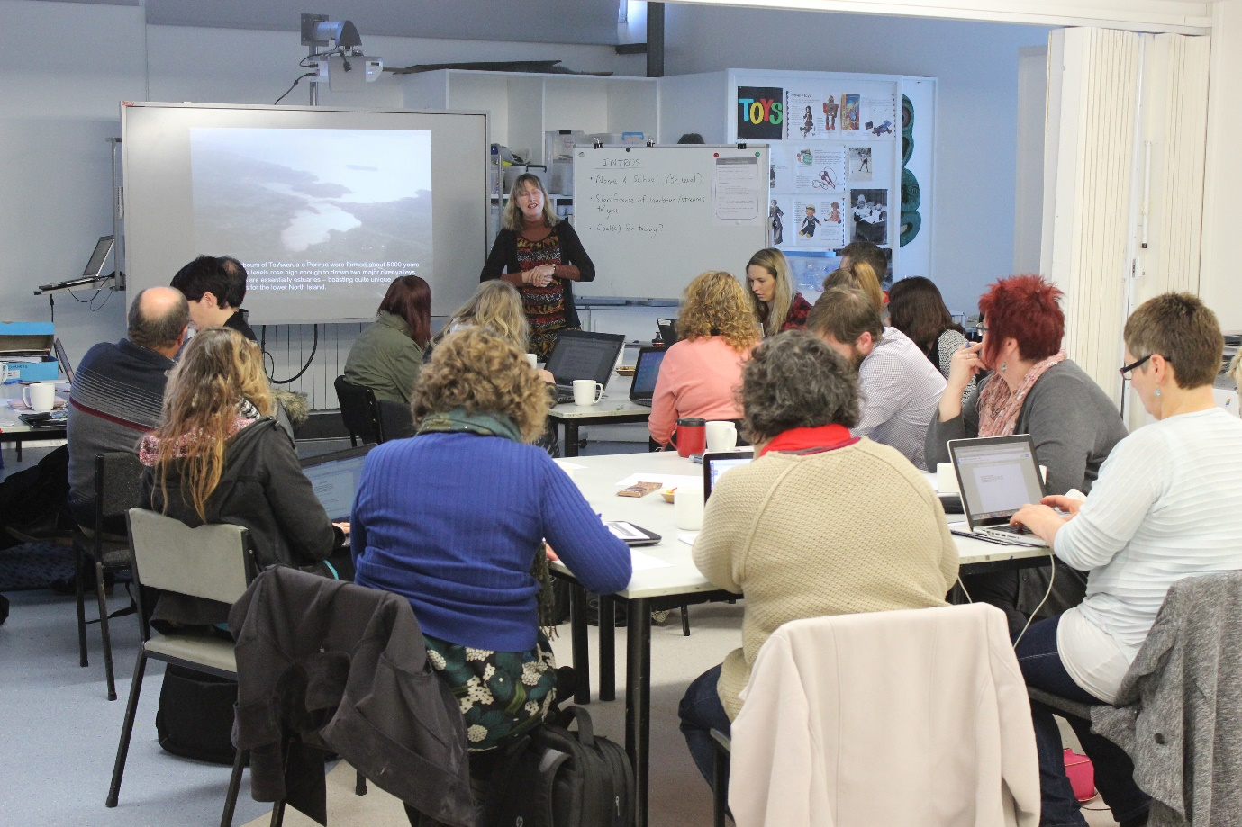
Above: Linda Fordyce (Pataka) discusses the early history of human settlement in the Porirua catchment area.
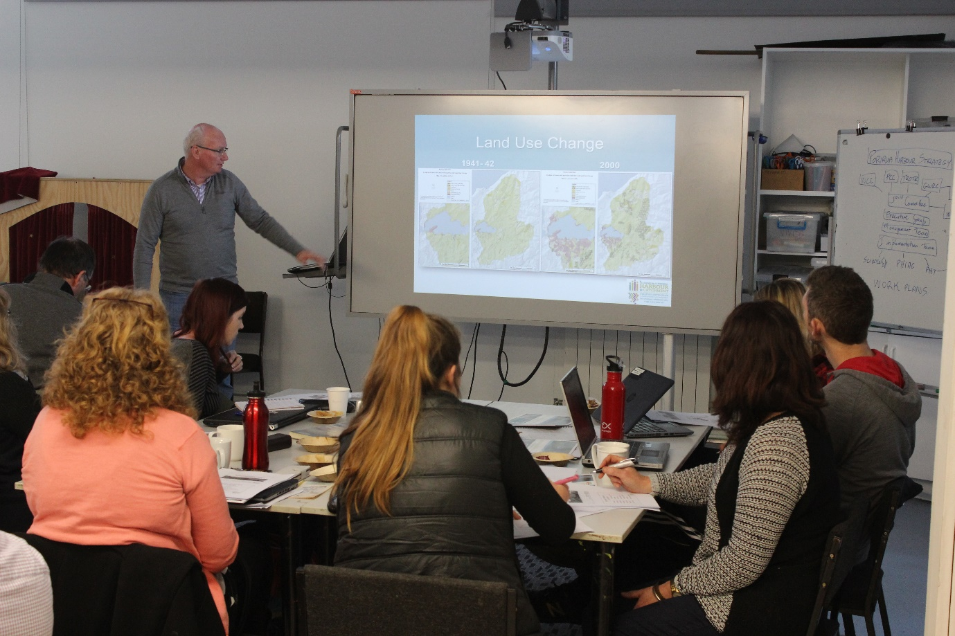
Above: Keith Calder (Porirua City Council) discusses the more recent impact of human development, and the future management of the harbour and catchment.
Teacher Feedback

A lot of positive feedback was received from teachers, who were really enthusiastic and motivated by the guest speakers, resources available and discussions during the day. The schools who have already been using the education resource, DVDs and catchment map have found them to be extremely useful and effective.

Some of the things teachers found useful, and some overall comments from the day:

“Was a great session, informative and interactive”
“Great use of local people to share their expertise. Nice to meet other local educators in a relaxed, informative setting.”
“Lots of ideas to incorporate into our inquiry plan, love the idea that the council are open to the children making a difference.”
“Speakers were excellent – very interesting.”
“Really enjoyed the in depth knowledge and passion from the presenters.”
“Lots of great information and resources to take back, and contacts for the future.”
“Rebecca was hands on with the whole group and small groups.”
“Very well organised and informative – great that it was a zero waste event”
“I have thoroughly enjoyed today and feel like I have gotten far more than I ever expected.”

Teachers would like more support with (including future PLD) or information about:

- Practical activities to do with students (how to translate ideas to the classroom)
- Field trips/field work about health of harbour/estuary/streams (clean ups, cockle count)
- Harbour Strategy and Action Plan (consequences for businesses if not compliant?)
- Maps of the catchment (comparing old and new, mapping activities for students)
- Ngati Toa’s involvement with the harbour
- Tour of the catchment looking at significant sites
- Slides (powerpoint) with photos showing human impact on the harbour

Suggestions for future of PHT’s education programme:

Get feedback from schools who have done the programme
Develop resources for younger students (Level 1 and 2) – eg Pop up storybook, photo packs
Create a video (or other artworks) made by students, to educate about the harbour
Portfolio of student work – as examples of what can be done
Use less paper, more digital resources (for teacher PLD)

Outcomes

Teachers from 13 schools were present at the workshop. Four of these schools (Plimmerton, St Brigid’s, Windley, Adventure) have already completed programmes about the harbour this year. Five schools (St Theresa’s, Ngati Toa, Tawa College, Mana College, Porirua College) are completing programmes in Term Four this year. The remaining schools (Churton Park, St Pius X, Titahi Bay, Bishop Viard) are planning units for 2016. See the Schools Summary Table for more details about their programmes and student action projects.

