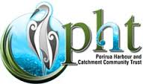

Te Awarua o Porirua Harbour and
Catchment Community Trust

Education Programme Annual Report 2018

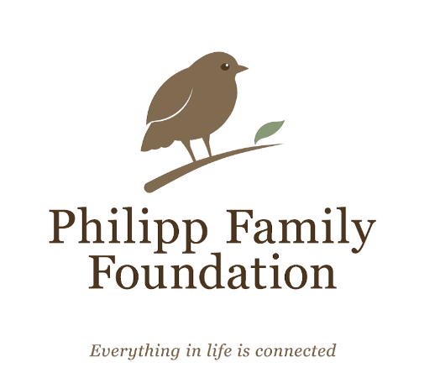

The Trust’s education programme is generously supported by the Philipp Family Foundation

Report prepared November 2018 by Rebecca McCormack (Education Coordinator)

INTRODUCTION
Schools in the catchment area for Te Awarua o Porirua Harbour are highly engaged with their local environment, and young people continue to be interested and concerned about the health of their local waterways. Thanks to the generous support of the Philipp Family Foundation, the Porirua Harbour Trust’s education programme has now been running for four years, and continues to strengthen and reach a wider number of schools.

Since the programme began in 2014, we have now engaged with 48 schools and have even added an extra two schools to our overall total for the catchment (up to 53, now that we are including Newlands School and Bellevue School). In 2018 we engaged directly with 33 schools, including running teacher professional learning events, providing resources and equipment, and helping with advice and support for student trips and action projects. Students at these schools are involved in a huge range of engaging learning programmes and projects, including (but not limited to):
- Trips to local streams, beaches, and areas of native bush (stream testing, marine surveys, planting)
- Waste and pollution reduction plans (litter-free lunchboxes, reusable bags, stormwater drain labelling, education campaigns)
- History and importance of the harbour to people, including advocating on behalf of communities (submissions to councils etc)
- Creativity (school productions, writing, murals)

Our programme is dependent on successful collaboration with many other individuals and organisations. We regularly collaborate with other educators from Enviroschools, Pātaka, Mountains to Sea Wellington, Sustainable Coastlines, Partners Porirua, Papa Taiao and many more. All of our teacher PLD events in 2018 have been in collaboration with Enviroschools, with particular support from Amanda Dobson and Arihia Latham.
We are very well supported by our councils (PCC, GWRC, WCC) and mana whenua (Ngāti Toa Rangatira), and would like to thank PCC and GWRC in particular for their support and funding contributions.

In October 2018 our education network began a collaborative evaluation process, with funding from PCC, GWRC and the Philipp Family Foundation. This project will produce an evaluative framework (by December), to help guide our evaluation and planning from 2019 onwards. We will then begin collecting and analysing evidence, by engaging with teachers and using evidence that is already collected by organisations in our education group.

This annual report summarises the outcomes from 2018, and also gives a summary of the plans for next year. The following pages are divided into two sections, based on the key areas of the education programme:
- Teacher Professional Support
- Engage and Empower Students: Creativity and Action

Note that this format differs from previous annual reports, where the outcomes and plans were divided into three sections (Schools, Stakeholders, Events). Hopefully the new format will reduce unnecessary overlaps, since all of these areas are very integrated.

TEACHER PROFESSIONAL SUPPORT

- Provide professional learning opportunities (PLD) and related resources for all schools in the catchment
- Advice and support for experiential learning activities, including suggested field trips; advice and support for student action projects.

GOALS (2018):
Engage with priority schools (schools still not engaged with programme), by trialing new PLD formats (holidays, different locations – Porirua Stream area).
Continue to support engaged schools, by providing new PLD content, resources and links to community and council projects (for student action projects).
Provide resources (maps, journals, books) and online support for teachers (PHT website, Padlet, Google docs etc).

OUTCOMES 2018 | GOALS and PLANS 2019
Total schools engaged (running total since 2014): 48/53  Schools who have taken part in teacher PLD (2014 – 2018): 47  Schools engaged with PHT coordinator in 2018: 33  Teacher PLD in 2018: 60 teachers, from 24 schools/ECE centres  PLD events: 3 full day workshops (March, July, Oct) and 3 after school hui.  These included a range of contexts and locations: extending knowledge of engaged teachers, using stream kits and marine surveys, introductory sessions for new schools.  We successfully engaged with the Newlands/Paparangi part of the catchment, with most of the schools in the area attending the teacher PLD in October at Seton Nossiter Park. This resulted in more schools (Newlands School and Bellevue) being added the total number of catchment schools (53), as these schools are located right on the edge of the catchment. We also invited two early childhood centres (ECE) to this PLD, to encourage vertical collaboration between teachers (ECE through to College).  Resources:  Catchment map is now in 27 schools.  The Current journal has been delivered to 35 schools.  Copies of books about streams/estuaries, teaching outdoors etc) given to 27 schools.  We also provide access to online resources (website and Padlet) to share with teachers.  Facilitated the loan of GWRC stream kits to 5 schools, including field trip support for Wellington SDA School. | Priority Schools (2019):  Not engaged: Tawa School, Tawa Int, Greenacres, Amesbury, Rewa Rewa  Low engagement: Schools who haven’t engaged with us for a few years, or have not maintained a long-term connection to streams/harbour (see list at end of School Summary Table).  I will continue to invite these schools to teacher PLD opportunities, and send specific invitations to principals and key teachers.  Engaged Schools:  Continue to offer PLD that extends and supports these schools, including offering to attend teacher-only days and staff meetings, to help build capacity with the whole staff.  Support schools to develop long-term and meaningful student projects in their local area, by connecting them with stakeholders and community groups. Promote authentic learning opportunities, such as the WWL wastewater engagement process, PCC’s District Plan changes etc.  Catchment map: Seek funding to print 50 more copies, as these are well-used by schools, and there are still 26 schools who don’t have them.  Continue to provide schools with other relevant resources, including books and teaching resources, particularly related to teacher PLD.

ENGAGE AND EMPOWER STUDENTS: CREATIVITY and ACTION

- Facilitate engagement with technical experts where applicable, such as scientists, council staff, and field trip providers; engage with key stakeholders.
- Advice and support for student action projects.
- Coordinate celebration events, publicity and partnerships e.g. creative arts projects and events.

GOALS (2018): Establish stronger links with DOC, WCC, Zealandia and community groups around the catchment.
Connect local artists with schools (plan for journal project in 2019), and facilitate schools visiting and engaging with relevant organisations.

OUTCOMES 2018 | GOALS and PLANS 2019
Creativity:  We funded a workshop at Linden School: Gillian Candler to ran a writing workshop and storytelling session, focused on native birds found around the harbour and Porirua Stream.  The Current journal is now in 37 schools, and the feedback from teachers, students and stakeholders has been very positive. Teachers are using them as a classroom resource, and have commented that students feel empowered seeing student work published, and that it provides an excellent starting point to encourage creativity and persuasive writing.  Planning has started for the next edition of the journal in 2019 (proposed funding and structure for the project, based on feedback and experiences from the first journal).  Student Agency and Action:  Supported the PCC student consultation workshop and helped support three schools with their submissions to the Long-Term Plan.  Met with students at Redwood School and Titahi Bay School to give advice and guidance around their planned action projects (e.g. planting, educating local community about stormwater pollution).  Collaborated with Enviroschools, Mountains to Sea Wellington, GWRC and PCC to provide support for student action projects and events (e.g. helping students plant at streams and use stream kits, supporting the Kaitiaki Ki a Kapiti event, advice/support for transport, logistics and equipment). | Creativity:  Produce the next edition of The Current student journal:  Secure funding for the project, including contracting Esme from Term 2.  Work with up to 8 schools, including at least 2 secondary schools.  Involve local artists, writers, community members (school workshops).  Ensure the process and design is authentically student-led.  Student Agency and Action:  Continue to collaborate with other educators, stakeholders and community groups to support opportunities for student action.  Support teachers/students to engage with opportunities for advocacy and community education, such as the WWL wastewater engagement process, PCC’s District Plan review, and other processes that arise.  Ensure schools are involved with authentic learning opportunities, such as the planned artificial wetland near Mana College, stream planting projects, waste reduction programmes (Sustainable Coastlines), biodiversity monitoring (marine, streams, birds) etc.  Continue to investigate the idea of a student leadership group, either for the whole harbour catchment area, or smaller groups to focus on advocacy and community education and action for their local stream/beach and green spaces (including school grounds).

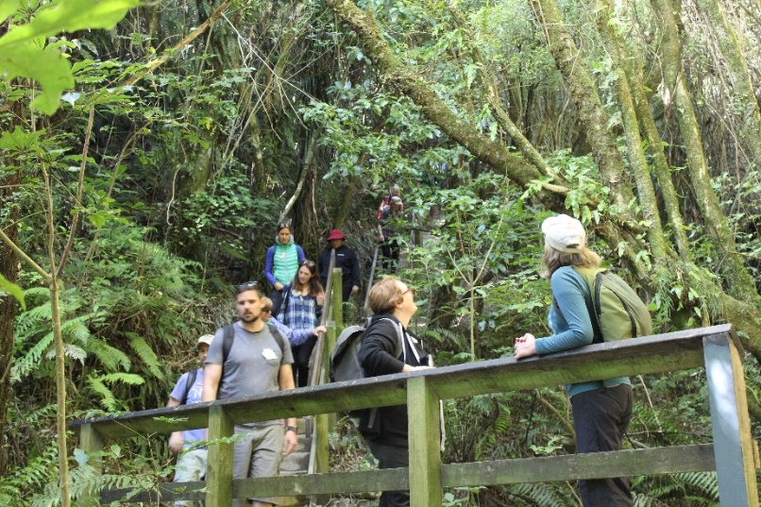
Porirua Harbour Trust
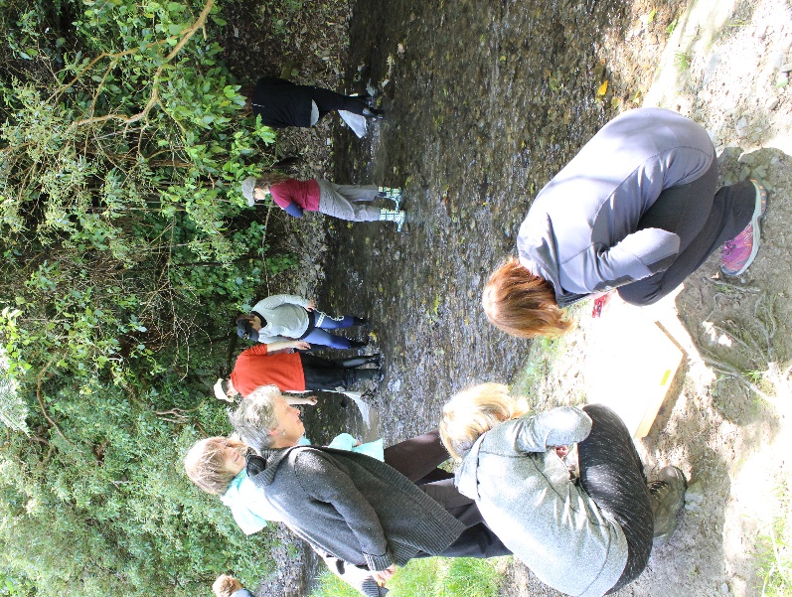
Education Programme 2018

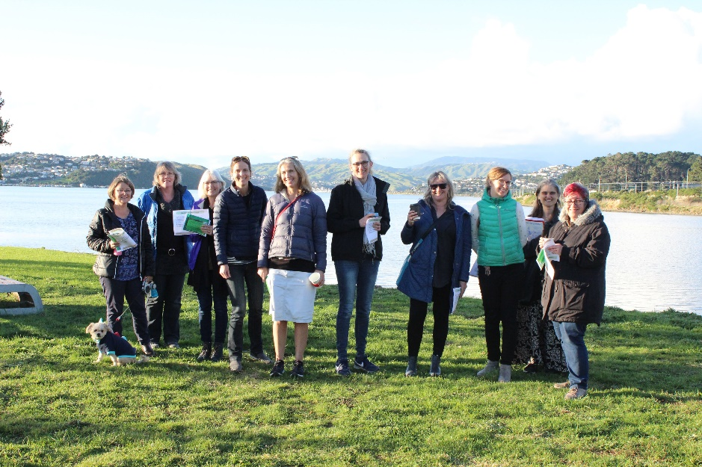

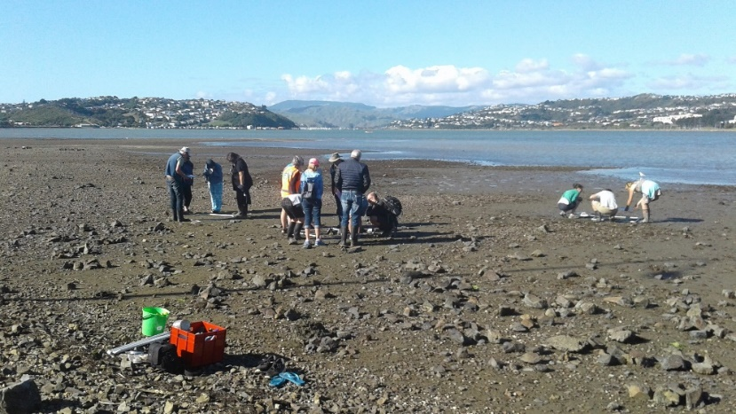

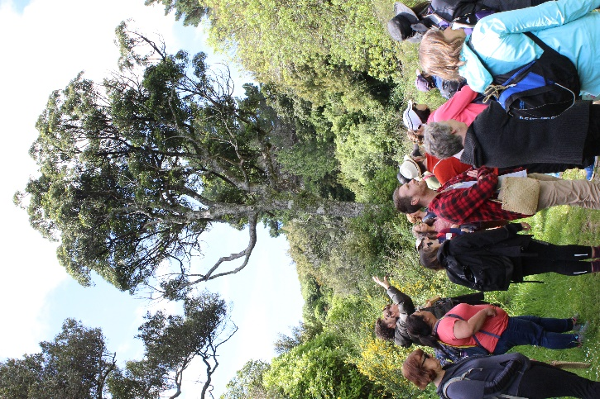
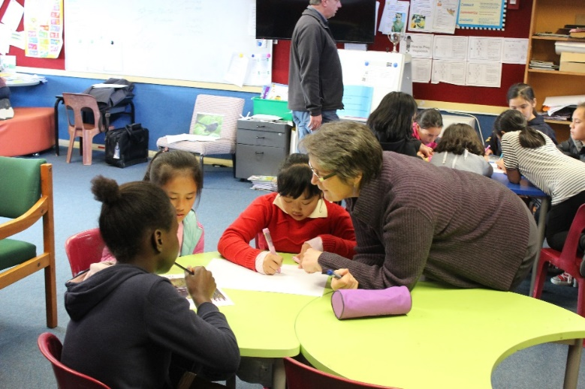
Paremata School
Gillian Candler at Linden School

SCHOOL SUMMARY TABLE – Updated November 2018

This table includes all of the schools in the Porirua Harbour catchment area (53 in total), and shows the level of engagement with the Trust’s education
programme, as well as other relevant environmental education programmes.

Table Key:
Enviroschool: region-wide environmental education programme.
MTSW: Mountains to Sea Wellington, includes Healthy Harbours Porirua and Whitebait Connection programmes (field work, class sessions, action projects)
Porirua Harbour Trust education programme: PLD = teacher professional learning and development, Map = school has copies of catchment map.
Highlighted schools have been identified as priority schools for 2019

School | Location | Year Levels | Decile | Enviroschool | MTSW | PLD 2014 | PLD 2015 | PLD 2016 | PLD 2017 | PLD 2018 | Art Projects | Have journals | Map | Learning Programme (including Field Trips) | Action Projects
Cannons Creek | P.East | 1 - 6 | 1 |  |  |  |  |  |  |  |  |  |  | Healthy Harbours (T1, 2016) | 2017: Working with Partners Porirua on Cannons Creek Lake project.
Glenview | P.East | 1 - 6 | 1 |  |  |  |  |  |  |  |  |  |  | Healthy Harbours T 1 2017 (stormwater focus) | Planting around Cannons Creek. Stormwater drain monitoring.
Holy Family | P.East | 1 - 6 | 1 |  |  |  |  |  |  |  |  |  |  | Healthy Harbours (T4, 2014) | Kenepuru Strm (planting).
Maraeroa | P.East | 1 - 6 | 1 |  |  |  |  |  |  |  |  |  |  | HHP hoping to engage in 2018 | Came to Mm2 workshop
Natone Park | P.East | 1 - 6 | 1 |  |  |  |  |  |  |  |  |  |  | Healthy Harbours T1, 2018 | Rubbish clean ups (and auditing) at  Te Awa Iti in Bothamley Park.
Porirua East | P.East | 1 - 6 | 3 |  |  |  |  |  |  |  |  |  |  | Healthy Harbours T1, 2018 | Stream testing
Russell | P.East | 1 - 6 | 1 |  |  |  |  |  |  |  |  |  |  | Estuaries unit (whole school), trip to Motukaraka Pt (2015) | ? (need to follow up)
Corinna | P.East | 1 - 8 | 1 |  |  |  |  |  |  |  | ‘16 |  |  | Science focus (2015), including looking at stream/harbour. 2016: Kaitiakitanga focus | Planting at Bothamley Park.  2017: plans for stream planting, community education, clean ups etc
Windley | P.East | 1 - 8 | 1 |  |  |  |  |  |  |  |  |  |  | Healthy Harbours (2015), trip to Pauatahanui Reserve | Kenepuru Strm (planting), Drain labels near school (2017).
Rangikura | Ascot Park | 1 - 8 | 2 |  |  |  |  |  |  |  | ‘17 |  |  | Healthy Harbours 2016 - 2018 | Planting, stream testing, trapping.
School | Location | Year Levels | Decile | Enviroschool | MTSW | PLD 2014 | PLD 2015 | PLD 2016 | PLD 2017 | PLD 2018 | Art Project | Have Journals | Map | Learning Programme (including Field Trips) | Action Projects
Tairangi | Waitangirua | 1 - 8 | 1 |  |  |  |  |  |  |  |  |  |  | HHP hoping to engage in 2018
Adventure | Whitby | 1 - 8 | 10 |  |  |  |  |  |  |  |  |  |  | Water unit (2015)), trip to Pauatahanui Reserve | Whitby Lake clean-up. Protecting inanga (Pauatahanui Stream)
Discovery | Whitby | 1 - 8 | 10 |  |  |  |  |  |  |  |  |  |  | Enviroschools – ‘friend of’, but quite actively involved | GWRC planting (Bothamley Park), stream testing at local stream.
Postgate | Whitby | 1 - 8 | 3 |  |  |  |  |  |  |  |  |  |  | Visiting local stream (2018) | Stream testing at local stream. Stormwater education.
Pāuatahanui | Pauatahanui | 1 - 8 | 10 |  |  |  |  |  |  |  |  |  |  | Pāuatahanui Wildlife Reserve. | Pest control.
Plimmerton | Plimmerton | 1 - 8 | 10 |  |  |  |  |  |  |  |  |  |  | Healthy Harbours (2015), Taupo Stream water testing | Beach clean ups
St Theresa's | Plimmerton | 1 - 6 | 10 |  |  |  |  |  |  |  | ’16 ‘17 |  |  | Healthy Harbours (2015), Taupo Stream. Art Project (puppets). | Clean-up and weed removal in  Taupo Stream. Waste-free lunches
Paremata | Paremata | 1 - 8 | 9 |  |  |  |  |  |  |  | ’16 ‘17 |  |  | Healthy Harbours 2017 | GWRC planting, wetland planting in school. Drain labels. Pest control.
Papakowhai | Papakowhai | 1 - 8 | 10 |  |  |  |  |  |  |  |  |  |  | Focus on P.stream and harbour each year. | Drain art, planting, animal pest control.
Pukerua Bay | Pukerua Bay | 1 - 8 |  |  |  |  |  |  |  |  | ‘16 |  |  | 2016: Focus on local environment, stream (Yr 7/8) | Drains are for Rains, labelling stormwater (PCC/Enviroschools)
St Pius X | T. Bay | 1 - 6 | 4 |  |  |  |  |  |  |  |  |  |  | Still in planning phase. | Keen to help with planting at local stream.
Titahi Bay | T. Bay | 1 - 6 | 4 |  |  |  |  |  |  |  | ‘17 |  |  | T2 2017: Whole school focus on water (seniors doing HHP). | Planting at Kahotea Strm, stormwater drain art, beach clean up
Ngāti Toa | T. Bay | 1 - 6 | 4 |  |  |  |  |  |  |  |  |  |  | Healthy Harbours (T4), Hukarito Stream. | Hukarito Stream restoration (ongoing project from end of 2015)
Titahi Bay North | T. Bay | 1 - 8 | 3 |  |  |  |  |  |  |  | ‘16 |  |  | Healthy Harbours (2015/16) Whole school focus in 2016. | Kahotea Stream project– ongoing monitoring, growing natives.
Porirua | Elsdon | 1 - 6 | 2 |  |  |  |  |  |  |  | ’16 ‘17 |  |  | Healthy Harbours (2015), Mahinawa Stream | Harbour clean ups and involved with Mahinawa Strm restoration.
Wellington SDA | Porirua | 1 - 8 | 2 |  |  |  |  |  |  |  |  |  |  | 2018 Stream testing Porirua Stream | Rubbish clean ups, stream testing, community education.
Linden | Tawa | 1 - 6 | 4 |  |  |  |  |  |  |  |  |  |  | Workshop with Gillian Candler 2018 | School veg gardens, interested in connecting with P. Strm
School | Location | Year Levels | Decile | Enviroschool | MTSW | PLD 2014 | PLD 2015 | PLD 2016 | PLD 2017 | PLD 2018 | Art Projects | Have Journals | Map | Learning Programme (including Field Trips) | Action Projects
Greenacres | Tawa | 1 - 6 | 9
Hampton Hill | Tawa | 1 - 6 | 6 |  |  |  |  |  |  |  |  |  |  | Healthy Harbours (2015),  Porirua Stream | Waste reduction and clean ups. Grasslees reserve bins (letter to WCC)
St Francis Xavier | Tawa | 1 - 6 | 9 |  |  |  |  |  |  |  |  |  |  | Some work on local stream/catchment. | Students designed/produced board games about tuna (native eels)
Redwood | Tawa | 1 - 6 | 10 |  |  |  |  |  |  |  |  |  |  | Senior students visited Harbour T2. | Planned action: educate community about stormwater pollution.
Tawa | Tawa | 1 - 8 | 7
Amesbury | Churton Park | 1 - 6 | 10 |  |  |  |  |  |  |  |  |  |  | Some involvement with Enviroschools.
Churton Park | Churton Park | 1 - 6 | 10 |  |  |  |  |  |  |  |  |  |  | 2017: Whitebait Connection | Stream clean ups, community education about Stebbings stream.
Johnsonville | J’ville | 1 - 6 | 9 |  |  |  |  |  |  |  |  |  |  | Enviroschool. | Waste reduction.
St Brigids | J’ville | 1 - 8 | 9 |  |  |  |  |  |  |  | ’16 ‘17 |  |  | Senior school focus on local stream/catchment (16/17). | Stream testing, clean ups. Pest trapping, rubbish-free lunchboxes.
Paparangi | Paparangi | 1 - 6 | 10 |  |  |  |  |  |  |  |  |  |  | 2016: Local stream study  2017: Whitebait connection | Native planting in school, waste reduction (Green-Gold Enviroschool).
Rewa Rewa | Newlands | 1 - 6 | 10 |  |  |  |  |  |  |  |  |  |  | Teacher signed up to Oct. PLD but was unable to attend.
Newlands | Newlands | 1 - 6 | 8 |  |  |  |  |  |  |  |  |  |  | Planning to engage with Belmont Stream more.
Bellevue | Newlands | 1 - 6 | 8 |  |  |  |  |  |  |  |  |  |  | Planning to engage with Belmont Stream more.
Intermediate
Brandon Inter. | P. East | 7 - 8 | 1 |  |  |  |  |  |  |  |  |  |  | Healthy Harbours T4 2016 | 2017: Cannons Creek fish passageway project (LTP submission)
Titahi Bay Inter. | T. Bay | 7 - 8 | 4 |  |  |  |  |  |  |  |  |  |  | Healthy Harbours (2015 & 2016) sustainability unit | 2016: Videos about waste reduction  2017: HHP, stormwater focus
Tawa Inter. | Tawa | 7 - 8 | 8 |  |  |  |  |  |  |  |  |  |  | Stream monitoring? Had staff training from HHP in 2016.
Newlands Inter. | Newlands | 7 - 8 | 9 |  |  |  |  |  |  |  |  |  |  |  | Connected to Belmont Stream planting project in the past.
School | Location | Year Levels | Decile | Enviroschool | MTSW | PLD 2014 | PLD 2015 | PLD 2016 | PLD 2017 | PLD 2018 | Art Projects | Have Journals | Map | Learning Programme (including Field Trips) | Action Projects
Bishop Viard | Porirua | 7-13 | 1 |  |  |  |  |  |  |  |  |  |  | Mentor programme, small group (Jnrs and Snrs) | Rubbish clean up along Porirua Stream (Conservation Volunteers)
Samuel Marsden | Whitby | 7-13 | n/a |  |  |  |  |  |  |  |  |  |  | Healthy Harbours (2015), with senior PE class.
Aotea College | Aotea | 9-13 | 5 |  |  |  |  |  |  |  |  |  |  | Healthy Harbours (2016). Plans for integrated project 2018. | 2016 Jnr SS: social action unit.  2017: Papa Taio - Pest control.
Mana College | Elsdon | 9-13 | 3 |  |  |  |  |  |  |  |  |  |  | Integrated programmes relating to harbour and stream (2016-17). | Mahinawa Stream restoration, fencing project.
Porirua College | P. East | 9-13 | 3 |  |  |  |  |  |  |  |  |  |  | Yr 9 Sci Term 1 (2016) – history of catchment area | Setting up native plant nursery (started in 2016).
Tawa College | Tawa | 9-13 | 8 |  |  |  |  |  |  |  |  |  |  | Yr 9 Sci/SS Harbour unit each year (2015 - 2017) 2016: Bio class focus on Porirua Stream. | Stream testing (Porirua & Belmont ). Drain labels (2017). Planting.
Newlands Coll. | Newlands | 9-13 | 9 |  |  |  |  |  |  |  |  |  |  | Plan to connect more with Belmont Stream from 2019. | Pest control and helping local ecosystems (weta hotels etc)
All Levels
Te Kura Maori o Porirua | P. East | 1-13 | 3 |  |  |  |  |  |  |  | ‘16 |  |  | Healthy Harbours (2015). Stream project in 2017. | Planting at Bothamley Park. Investigating local stream (monitoring, planting etc).
Mahinawa Specialist | Porirua | 1-13 | 5

Priority Schools for 2019:
Not engaged: Tawa School, Tawa Intermediate, Greenacres, Amesbury, Rewa Rewa, (Mahinawa Specialist School)

Low engagement (or newly engaged): Maraeroa, Russell, Windley, Tairangi, St Pius X, Linden, St Francis Xavier, Redwood, Newlands, Bellevue, Newlands Intermediate, Titahi Bay Intermediate, Bishop Viard, Samuel Marsden, Newlands College

